# RFP: RAN Quality Evaluator

## Requirement List

### Result Analysis

* Evaluation Result:
  + Pass: All KPIs Pattern Pass
  + Fail: At least one KPI Pattern Fail
  + Restored: At least one KPI Pattern Restored, and the others KPI Pattern Pass
* KPI Pattern Result
  + Pass
  + Fail
  + Restored
* KPI Pattern Type: 9 Possibles KPI Pattern Type

Settings:

* + threshold: 5%
  + period: 7 days
  + guard: 7 days

Measure Ranges:

* + Before: [input_date – guard – period; input_date – guard]
  + After: [input_date + guard; input_date + guard + period]
  + Last: [max_date – period; max_date]

Indicators:

* + Site Compound Quality Indicators: umts_cqi, lte_cqi, nr_cqi
  + Site Traffic Data (traffic_data) 3G_PS + 4G_PS + 5G_PS
  + Site Traffic Voice (traffic_voice): 3G_CS + VoLTE.
  + Neighbor Compound Quality Indicators: umts_cqi, lte_cqi, nr_cqi
  + Neighbor Traffic Data (traffic_data) 3G_PS + 4G_PS + 5G_PS
  + Neighbor Traffic Voice (traffic_voice): 3G_CS + VoLTE

Methodology:

* + Calculate Average during Measure Range
  + Calculate the variation between Measure Ranges
  + Categorize the variation in one of the 9 KPI Pattern Types, 3 KPI Pattern Results.

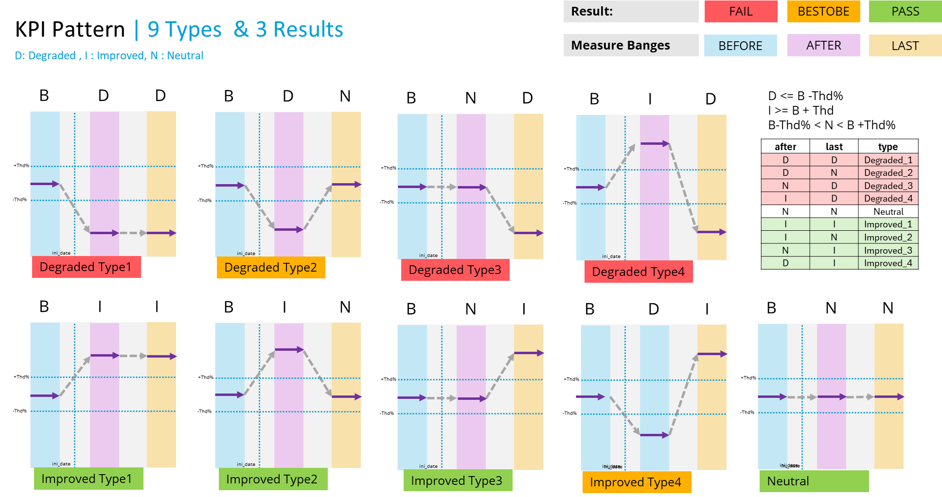

### Site Analysis

Create plot using the site counters for neighbor list then calculate

* User Inputs:
  + site_att
  + input_date
* input_date recommendation
  + list of dates with cell qty variation (3g, 4g)
* Plot01
  + - period: [input_date – 30; max_date]
    - KPI Type: line continue
    - KPI: Site Compound Quality Indicators: umts_cqi, lte_cqi, nr_cqi
    - Vertical Lines: dotted line
    - Vertical: before, after, last limits
* Plot02
  + - period: [input_date – 30; max_date]
    - KPI Type: stacked bar
    - KPI: Site Traffic Data (traffic_data) 3G_PS + 4G_PS + 5G_PS
    - Vertical Lines: dotted line
    - Vertical: before, after, last limits
* Plot03
  + - period: [input_date – 30; max_date]
    - KPI Type: stacked bar
    - KPI: Site Traffic Voice (traffic_voice): 3G_CS + VoLTE.
    - Vertical Lines: dotted line
    - Vertical: before, after, last limits

### Neighbor Analysis

Create plot grouping (sum) all the counters for neighbor list then calculate

* Plot04
  + - Geolocated_Map
    - site_att -> green
    - neighbor sites-> yellow
* Plot05:
  + - period: [input_date – 30; max_date]
    - KPI Type: line continue
  + KPI: Neighbor Compound Quality Indicators: umts_cqi, lte_cqi, nr_cqi
    - Vertical Lines: dotted line
    - Vertical: before, after, last limits
* Plot06
  + - period: [input_date – 30; max_date]
    - KPI Type: stacked bar
  + KPI: Neighbor Traffic Data (traffic_data) 3G_PS + 4G_PS + 5G_PS
    - Vertical Lines: dotted line
    - Vertical: before, after, last limits
* Plot07
  + - period: [input_date – 30; max_date]
    - KPI Type: stacked bar
  + KPI: Neighbor Traffic Voice (traffic_voice): 3G_CS + VoLTE
    - Vertical Lines: dotted line
    - Vertical: before, after, last limits

### Report Results

* + - * All the previous results in a pdf format.

